
同济大学

《数据库技术与应用》
项目设计报告

项目设计报告题目：
轴心受力构件工具箱
小组成员姓名 ：__ 1953961黄芷仪___________
__ 2054136唐音奇_____________
__ 2152017钱浦玥_____________
__ 1753067林秩佳_____________
班级： 10053601
年级： 17/19/20/21级 专业： 城乡规划 /工程管理
指导教师： 袁科萍
日期： 2023 年 6 月 8 日

项目设计报告内容
- 项目设计的目的和意义
1.1项目开发背景
随着计算机技术迅速断发展，人们逐渐依赖于各种计算工具高效自主计算设计。作为建筑结构中常用的构件形式，轴心构件计算是建筑设计和施工中的核心部分，也是建筑结构及力学课程的重点内容。因此，建立一个方便快捷的计算工具，对于顺应市场需求、培养学习能力有重要意义。本项目为建立一个钢筋混凝土配筋计算工具箱，主要内容是实现轴心受力构件承载力计算以及相应的配筋设计，其使用对象包括审图人员、结构工程师和相关专业的学生等。

1.2具体目的及意义
（1）提高计算效率。使用者可以减少繁琐公式和数据带来的计算量，填入已知量得到所需结果，进行快速计算和设计。
（2）提高计算准确度。使用该工具箱能够避免人为操作中的计算错误和误差。
（3）系统总结了轴心构建中的基本钢筋、混凝土种类和已知性质，便于使用者的对钢筋混凝土材料性质的快速查找和学习。

- 项目主要功能描述
（1）在主页面提供本工具箱的基础功能及内容介绍，方便用户快速上手。
（2）为使用者提供钢筋、混凝土的种类、强度等级、弹性模量等数据的查询服务。
（3）使用者可输入构件截面面积、选择材料参数等数据，进行四种轴心受力构件的承载力及配筋计算，具体包括轴心受压构件的承载力计算、配筋计算及轴心受压构件的承载力计算与配筋设计。

- 数据库设计
3.1数据需求分析
本项目建立了一个包含查询与计算设计的工具箱，能够有效减少用户手动计算的工作量，提高计算精度。此项目计算设计所需要的数据包括钢筋、混凝土的种类、各种强度值与弹性模量等，通过这些基本数据即可计算所需构件的承载力与配筋设计。

3.2概念模式设计（E-R图设计）
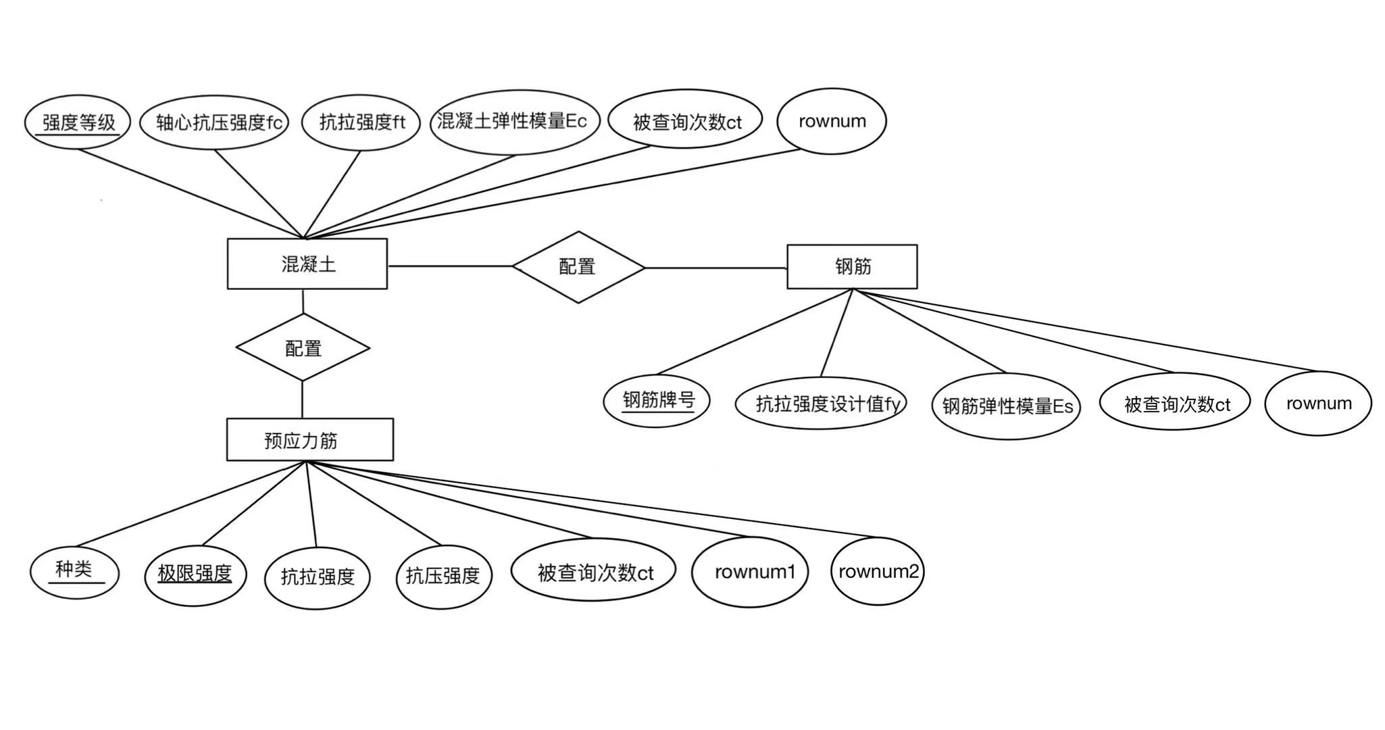
3.3逻辑模式设计
混凝土（强度等级，轴心抗压强度fc，抗拉强度ft，混凝土弹性模量Ec，被查询次数ct，rownum）
钢筋（钢筋牌号，抗拉强度设计值fy，钢筋弹性模量Es，被查询次数ct，rownum）
预应力筋（种类，极限强度，抗拉强度，抗压强度，被查询次数ct，rownum1，rownum2）

3.4数据库实施
- 数据库Reinforced_concrete
CREATE DATABASE Reinforces_concrete
- 表Concrete
CREATE TABLE Concrete
(
Strength CHAR(3)NOT NULL PRIMARY KEY
CHECK(Strength like 'C[0-9][0-9]'),
fc DOUBLE,
ft DOUBLE,
Ec INT
)
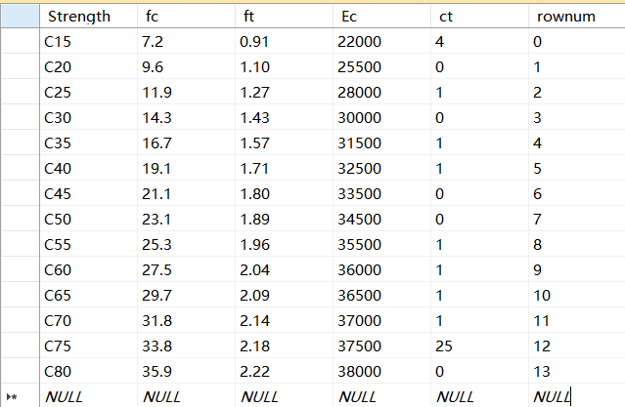
- 表Steel
CREATE TABLE Steel
(
brand CHAR(6)NOT NULL PRIMARY KEY
CHECK(Strength like 'C[0-9][0-9][0-9]'),
fy INT,
Es INT
)
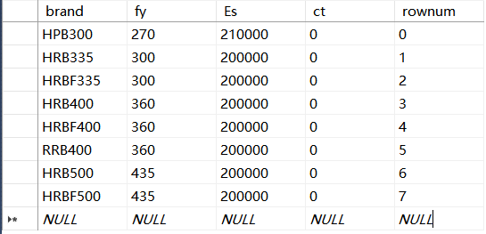
- 表Prestressed reinforcement
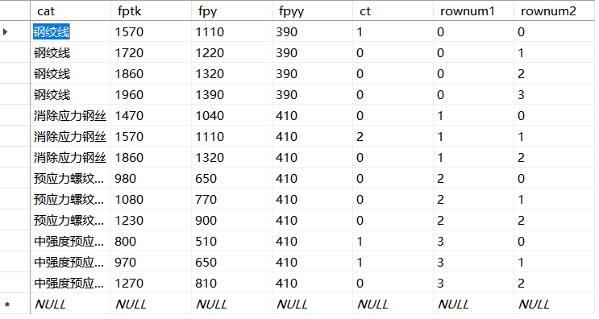

- 功能窗体设计与代码设计
4.1 系统运行逻辑流程图
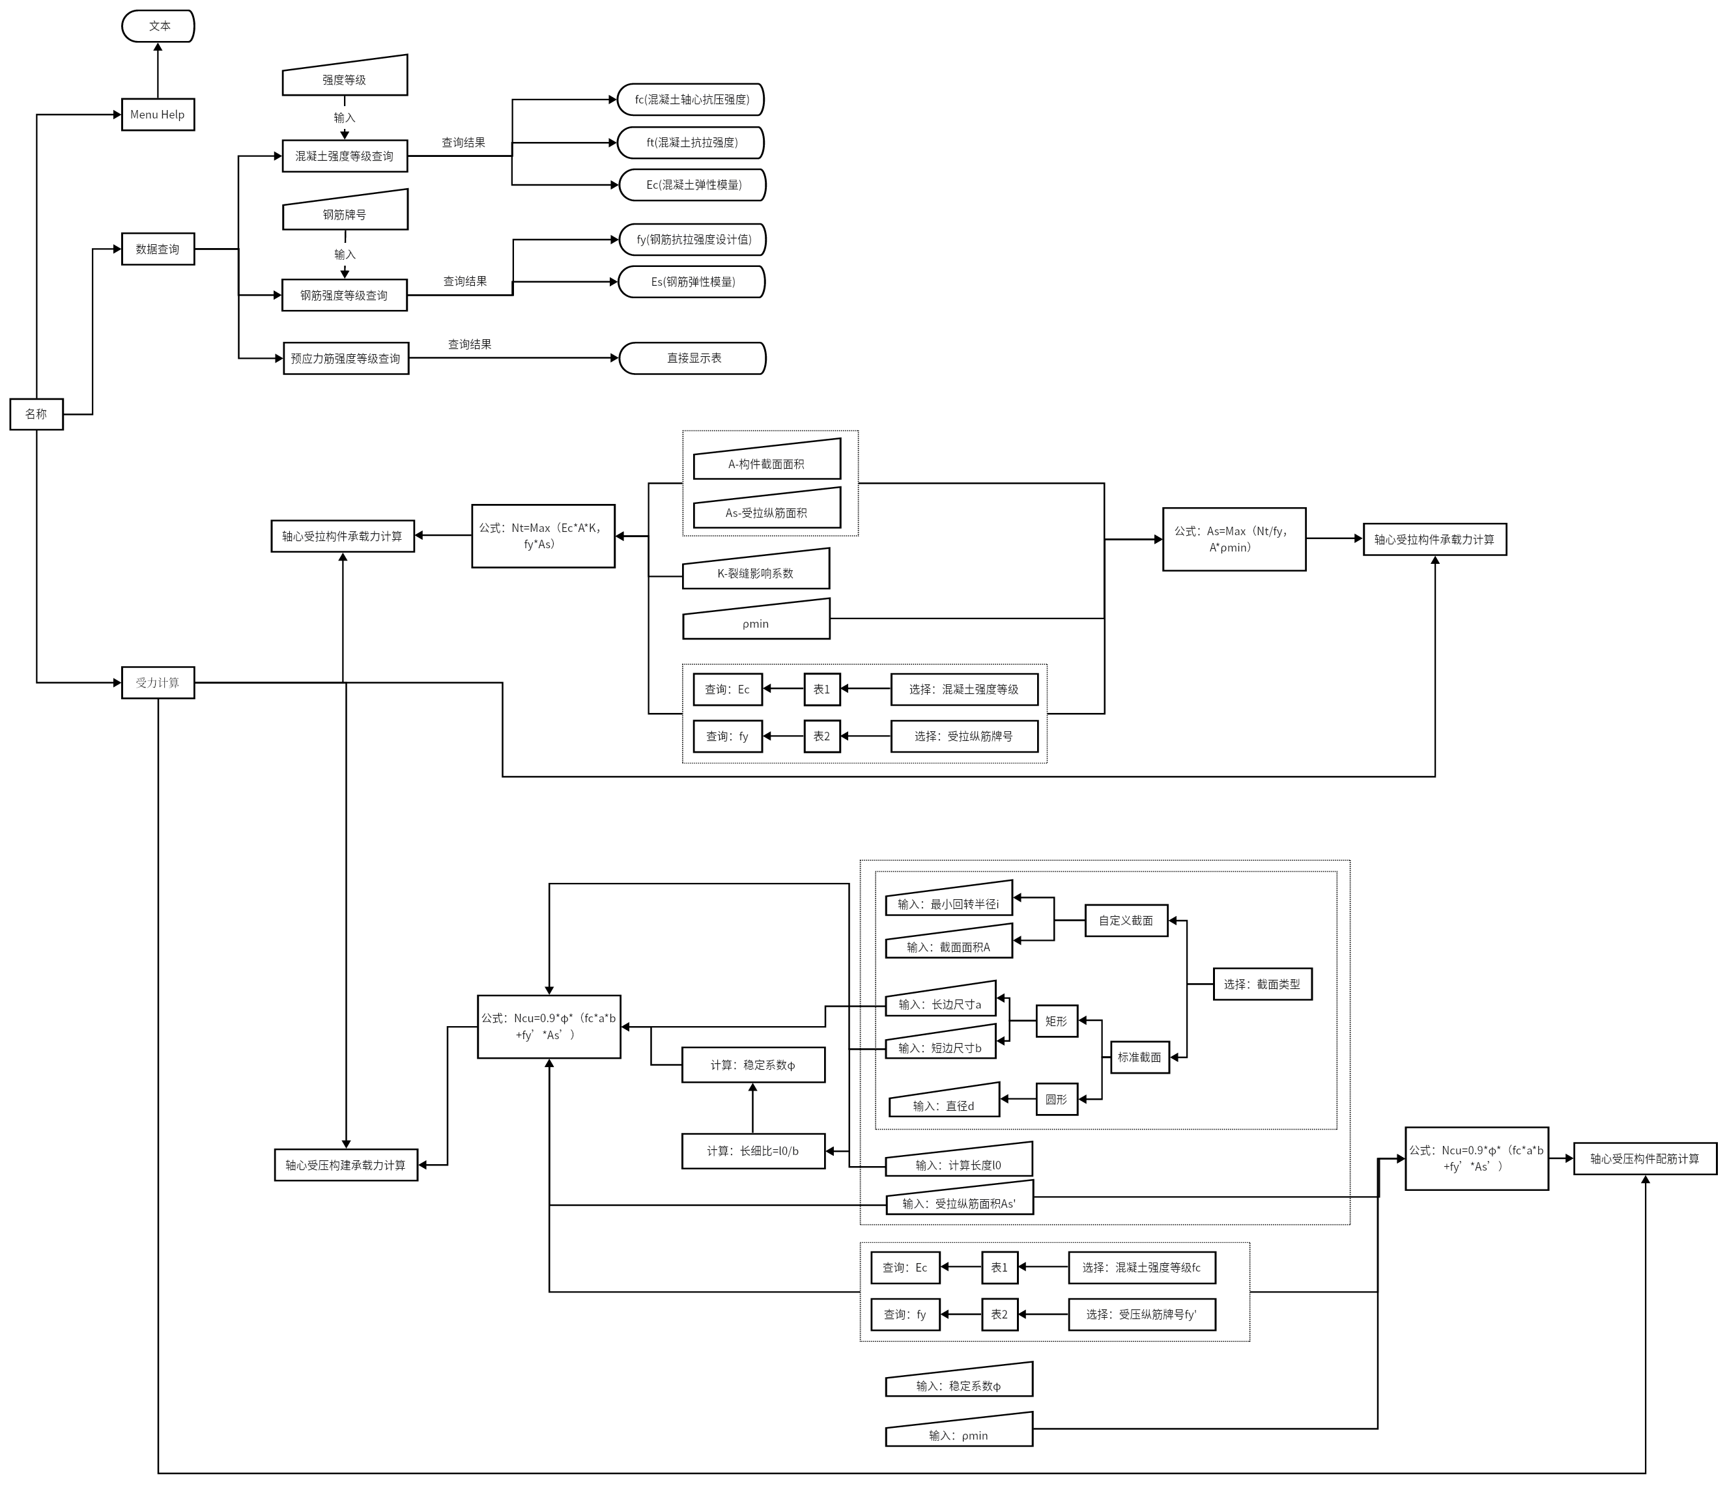
4.2 主菜单
1）代码实施：跳转页面
public partial class Form1 : Form
{
public Form1()
{
InitializeComponent();
}

private void button2_Click(object sender, EventArgs e)
{

}

private void button3_Click(object sender, EventArgs e)
{
Form2 fr = new Form2();
fr.ShowDialog();
}
- 页面设计
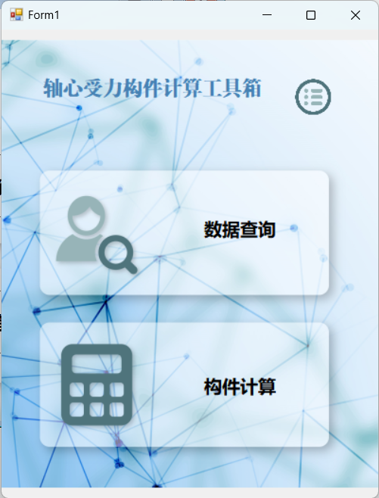
4.3 软件使用说明页面
1）代码实施：跳转页面
private void button3_Click(object sender, EventArgs e)
{
this.Close();
}
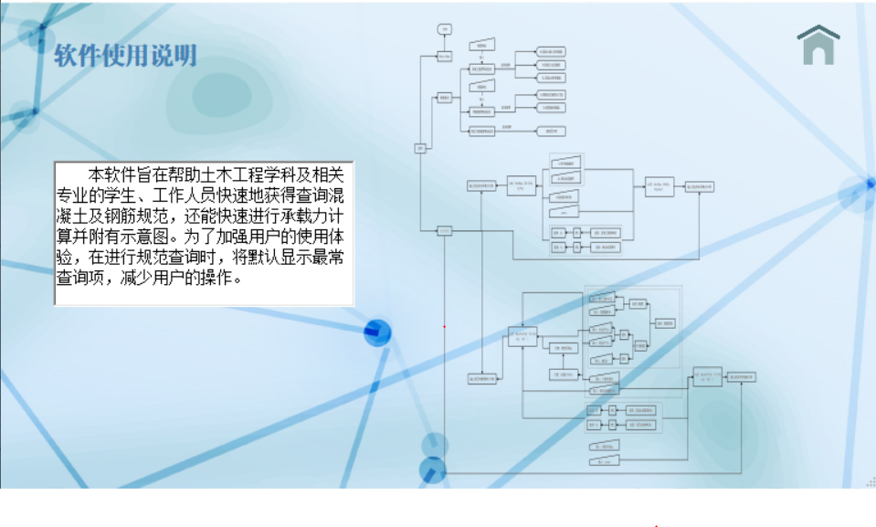
- 页面设计
4.4 数据查询页面
4.4.1 主页面设计
1）Tabcontrol 应用
//单独设立tabcontrol页面，将其他form链入此页面
q1 tabpageform1 = new q1();
rebar tabpageform2 = new rebar();
q3 tabpageform3 = new q3();
List<Form> formList = new List <Form>();
private void tabcontrol_Load(object sender, EventArgs e)
{
formList.Add(tabpageform1);
formList.Add(tabpageform2);
formList.Add(tabpageform3);
for (int i=0; i<tabControl1.TabPages.Count ;i++)
{
if(i>=formList.Count)
break;
Form f = formList[i];
f.Dock=DockStyle.Fill;
f.TopLevel=false;
f.FormBorderStyle=FormBorderStyle.None;
f.Show();
tabControl1.TabPages[i].Controls.Clear();
tabControl1.TabPages[i].Controls.Add(f);
}
}
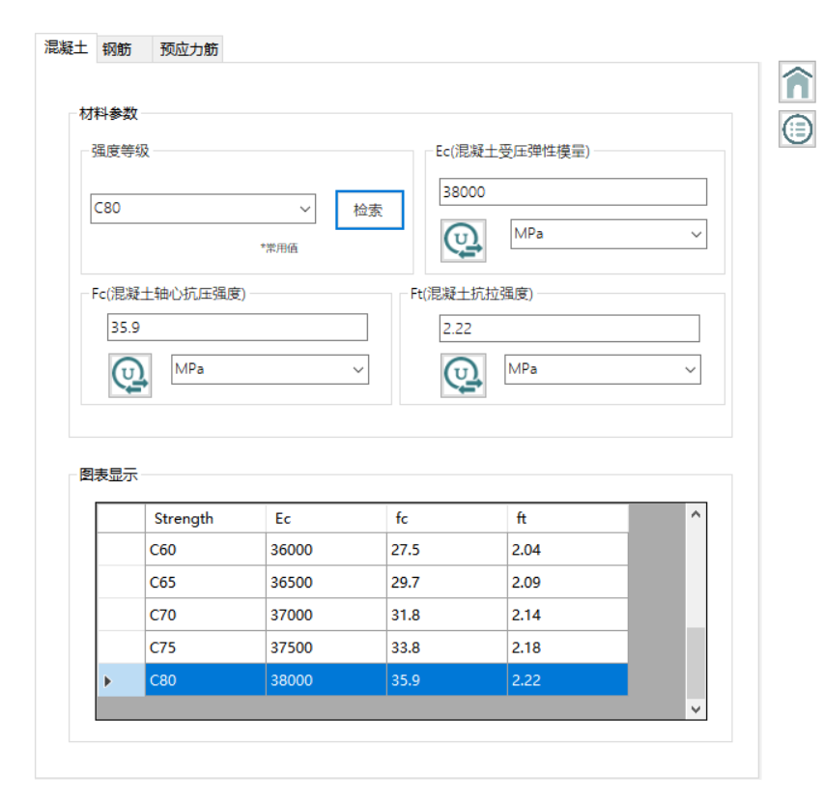
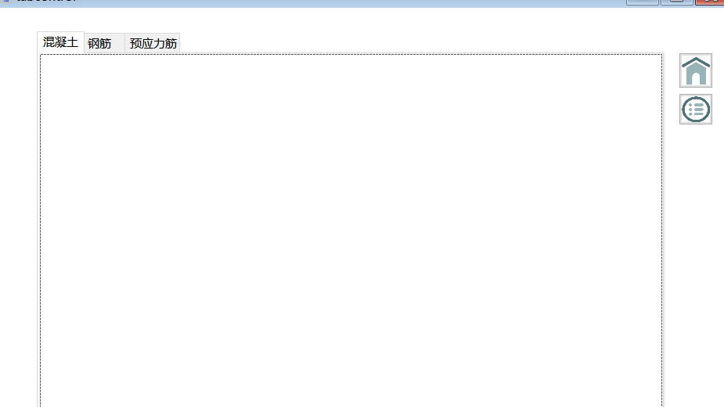
- 页面设计
4.4.2 混凝土强度等级查询
1）代码实施
//建立sql连接
SqlConnection myconn = new SqlConnection(@"Data Source=LAPTOP-91SDKBLS\SHUJUKU;Initial Catalog=reinforce_concrete2;Integrated Security=True");
static double a;
static double b;
static double c;

private void q1_Load(object sender, EventArgs e)
{
//填充combobox
SqlDataAdapter myadapter = new SqlDataAdapter("select strength from Concrete", myconn);
DataSet mydataset = new DataSet();
myadapter.Fill(mydataset, "hunningtu");
comboBox1.DataSource = mydataset.Tables["hunningtu"];
comboBox1.DisplayMember = "strength";
myconn.Close();
//查询被查询次数最多的项
int j=0,m=0;
SqlCommand mycmd = new SqlCommand("select max(ct) from Concrete" , myconn);
SqlDataReader mydatareader;
myconn.Open();
{
mydatareader = mycmd.ExecuteReader();
mydatareader.Read();
j = int.Parse(mydatareader.GetValue(0).ToString());
mydatareader.Close();
}
myconn.Close();
//默认显示被查询次数最多的项
mycmd = new SqlCommand("select rownum from Concrete where ct=" + j, myconn);
myconn.Open();
{
mydatareader = mycmd.ExecuteReader();
mydatareader.Read();
j = int.Parse(mydatareader.GetValue(0).ToString());
mydatareader.Close();
}
myconn.Close();
comboBox1.SelectedIndex = j;
//第一项combobox运行即查询，因此对计数器进行修正
mycmd = new SqlCommand("select ct from Concrete where rownum=0", myconn);
myconn.Open();
{
mydatareader = mycmd.ExecuteReader();
mydatareader.Read();
m = int.Parse(mydatareader.GetValue(0).ToString());
mydatareader.Close();
}
myconn.Close();
m = m - 1;
string cmd = "update Concrete set ct=" + m + "where rownum=0";
mycmd = new SqlCommand(cmd, myconn);
myconn.Open();
{
try
{
mycmd.ExecuteNonQuery();
}
catch (Exception ex)
{
MessageBox.Show(ex.ToString());
}
}
myconn.Close();
//查询并赋值给表
comboBox2.SelectedIndex = 0;
comboBox3.SelectedIndex = 0;
comboBox4.SelectedIndex = 0;
myadapter = new SqlDataAdapter("select Strength,Ec,fc,ft from Concrete", myconn);
myadapter.Fill(mydataset, "hunning");
dataGridView1.DataSource = mydataset.Tables["hunning"];
myconn.Close();

}

private void comboBox1_SelectedIndexChanged(object sender, EventArgs e)
{
int countt=0;
SqlCommand mycmd = new SqlCommand("select Ec,fc,ft,ct from Concrete where strength ='" + comboBox1.Text +"'", myconn);
SqlDataReader mydatareader;
myconn.Open();
{
//根据输入查询，并在计数器中记录此次查询
mydatareader = mycmd.ExecuteReader();
mydatareader.Read();
if (mydatareader.HasRows)
{
textBox1.Text = mydatareader.GetValue(0).ToString();
textBox2.Text = mydatareader.GetValue(1).ToString();
textBox3.Text = mydatareader.GetValue(2).ToString();
countt = int.Parse(mydatareader.GetValue(3).ToString());
countt++;
}
mydatareader.Close();
}
myconn.Close();

a = double.Parse(textBox1.Text);
b = double.Parse(textBox2.Text);
c = double.Parse(textBox3.Text);

string cmd = "update Concrete set ct=" + countt + "where strength='" + comboBox1.Text + "'";
mycmd = new SqlCommand(cmd, myconn);
myconn.Open();
{
try
{
mycmd.ExecuteNonQuery();
}
catch (Exception ex)
{
MessageBox.Show(ex.ToString());
}
}
myconn.Close();
}
//单位换算
private void button1_Click(object sender, EventArgs e)
{

switch (comboBox2.Text)
{
case "MPa": textBox1.Text = a.ToString(); break;
case "KPa": textBox1.Text = (a * 1000).ToString(); break;
case "HPa": textBox1.Text = (a * 10000).ToString(); break;
case "Pa": textBox1.Text = (a * 1000000).ToString(); break;
case "atm": textBox1.Text = (a * 9.8692327).ToString(); break;
case "mmHg": textBox1.Text = (a * 7500.616827).ToString(); break;
}
}
//查询所得项在表格中高亮显示
private void button4_Click(object sender, EventArgs e)
{
int i = 0;
while (i < 14)
{
if (dataGridView1[0, i].Value.ToString() == comboBox1.Text)
{
dataGridView1.CurrentCell = dataGridView1[0, i];
dataGridView1.Rows[i].Selected = true;

break;
}
i++;
}
}
- 页面设计
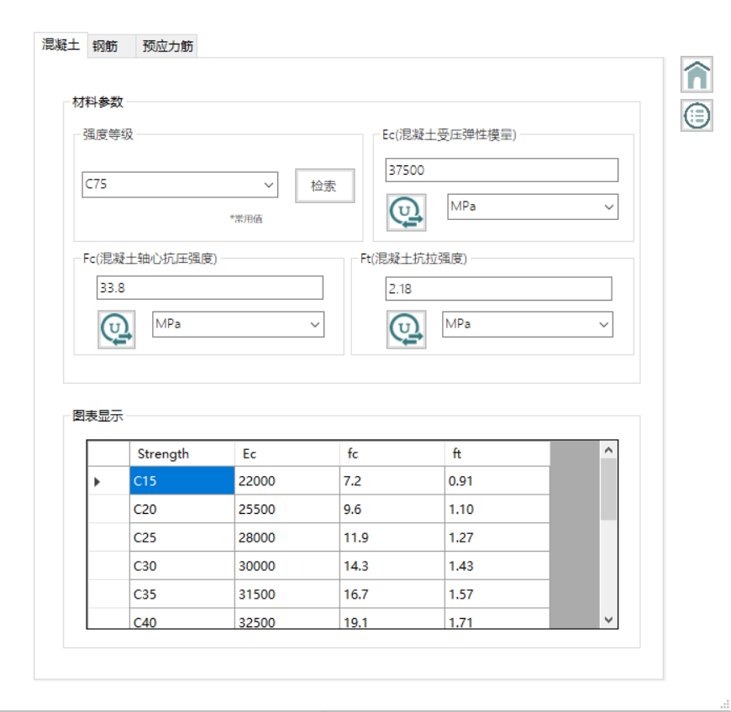
4.4.3 钢筋强度等级查询
1）代码实施
//建立sql连接
SqlConnection myconn = new SqlConnection(@"Data Source=LAPTOP-91SDKBLS\SHUJUKU;Initial Catalog=reinforce_concrete2;Integrated Security=True");
static double d;
static double ee;
//填充combobox

private void rebar_Load(object sender, EventArgs e)
{
SqlDataAdapter myadapter = new SqlDataAdapter("select brand from Strength", myconn);
DataSet mydataset = new DataSet();
myadapter.Fill(mydataset, "gangjin");
comboBox5.DataSource = mydataset.Tables["gangjin"];
comboBox5.DisplayMember = "brand";
myconn.Close();
//查询被查询次数最多的项
int j = 0, m = 0;
SqlCommand mycmd = new SqlCommand("select max(ct) from Strength", myconn);
SqlDataReader mydatareader;
myconn.Open();
{
mydatareader = mycmd.ExecuteReader();
mydatareader.Read();
j = int.Parse(mydatareader.GetValue(0).ToString());
mydatareader.Close();
}
myconn.Close();
//默认显示被查询次数最多的项
mycmd = new SqlCommand("select rownum from Strength where ct=" + j, myconn);
myconn.Open();
{
mydatareader = mycmd.ExecuteReader();
mydatareader.Read();
j = int.Parse(mydatareader.GetValue(0).ToString());
mydatareader.Close();
}
myconn.Close();
comboBox5.SelectedIndex = j;

mycmd = new SqlCommand("select ct from Strength where rownum=0", myconn);
myconn.Open();
{
mydatareader = mycmd.ExecuteReader();
mydatareader.Read();
m = int.Parse(mydatareader.GetValue(0).ToString());
mydatareader.Close();
}
myconn.Close();
//第一项combobox运行即查询，因此对计数器进行修正

m = m - 1;
string cmd = "update Strength set ct=" + m + "where rownum=0";
mycmd = new SqlCommand(cmd, myconn);
myconn.Open();
{
try
{
mycmd.ExecuteNonQuery();
}
catch (Exception ex)
{
MessageBox.Show(ex.ToString());
}
}
myconn.Close();
//查询并赋值给表
comboBox6.SelectedIndex = 0;
comboBox7.SelectedIndex = 0;
myadapter = new SqlDataAdapter("select brand,fy,Es from Strength", myconn);
myadapter.Fill(mydataset, "gang");
dataGridView2.DataSource = mydataset.Tables["gang"];
myconn.Close();
}
//根据输入查询，并在计数器中记录此次查询
private void comboBox5_SelectedIndexChanged(object sender, EventArgs e)
{
int countt = 0;
SqlCommand mycmd = new SqlCommand("select fy,Es,ct from Strength where brand ='" + comboBox5.Text + "'", myconn);
SqlDataReader mydatareader;
myconn.Open();
{
mydatareader = mycmd.ExecuteReader();
mydatareader.Read();
if (mydatareader.HasRows)
{
textBox4.Text = mydatareader.GetValue(0).ToString();
textBox5.Text = mydatareader.GetValue(1).ToString();
countt = int.Parse(mydatareader.GetValue(2).ToString());
countt++;
}
mydatareader.Close();
}
myconn.Close();

d = double.Parse(textBox4.Text);
ee = double.Parse(textBox5.Text);

string cmd = "update Strength set ct=" + countt + "where brand ='" + comboBox5.Text + "'";
mycmd = new SqlCommand(cmd, myconn);
myconn.Open();
{
try
{
mycmd.ExecuteNonQuery();
}
catch (Exception ex)
{
MessageBox.Show(ex.ToString());
}
}
myconn.Close();
}
//单位换算
private void button6_Click(object sender, EventArgs e)
{
switch (comboBox6.Text)
{
case "MPa": textBox4.Text = d.ToString(); break;
case "KPa": textBox4.Text = (d * 1000).ToString(); break;
case "HPa": textBox4.Text = (d * 10000).ToString(); break;
case "Pa": textBox4.Text = (d * 1000000).ToString(); break;
case "atm": textBox4.Text = (d * 9.8692327).ToString(); break;
case "mmHg": textBox4.Text = (d * 7500.616827).ToString(); break;
}
}

private void button7_Click(object sender, EventArgs e)
{
switch (comboBox7.Text)
{
case "MPa": textBox5.Text = ee.ToString(); break;
case "KPa": textBox5.Text = (ee * 1000).ToString(); break;
case "HPa": textBox5.Text = (ee * 10000).ToString(); break;
case "Pa": textBox5.Text = (ee * 1000000).ToString(); break;
case "atm": textBox5.Text = (ee * 9.8692327).ToString(); break;
case "mmHg": textBox5.Text = (ee * 7500.616827).ToString(); break;
}
}
//查询所得项在表格中高亮显示
private void button5_Click(object sender, EventArgs e)
{
int i = 0;
while (i < 8)
{
if (dataGridView2[0, i].Value.ToString() == comboBox5.Text)
{
dataGridView2.CurrentCell = dataGridView2[0, i];
dataGridView2.Rows[i].Selected = true;
break;
}
i++;
}
}
- 页面设计
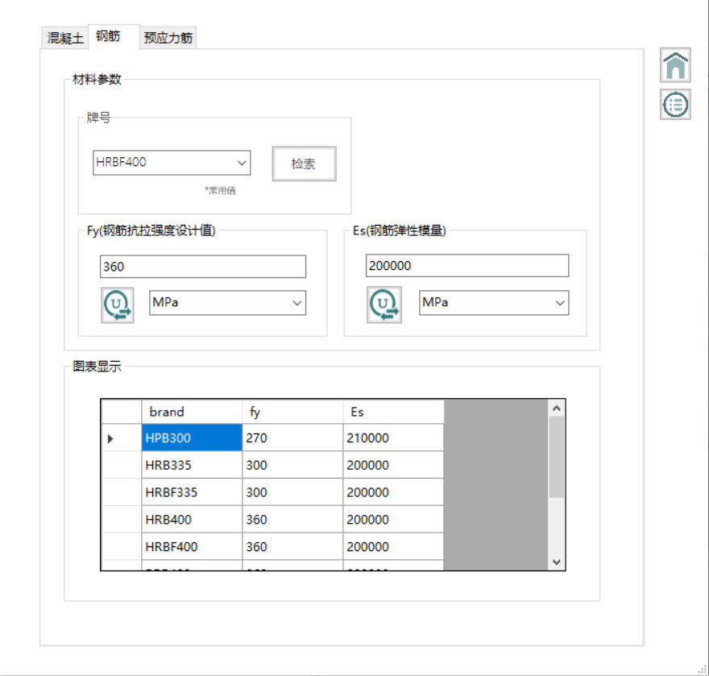

4.4.4 预应力筋强度等级查询
1)代码实现
//建立sql连接
SqlConnection myconn = new SqlConnection(@"Data Source=LAPTOP-91SDKBLS\SHUJUKU;Initial Catalog=reinforce_concrete2;Integrated Security=True");
static double a;
static double b;
//填充combobox
private void q3_Load(object sender, EventArgs e)
{
SqlDataAdapter myadapter = new SqlDataAdapter("select distinct cat from pc1", myconn);
DataSet mydataset = new DataSet();
myadapter.Fill(mydataset, "yuying1");
comboBox1.DataSource = mydataset.Tables["yuying1"];
comboBox1.DisplayMember = "cat";
myconn.Close();

int j = 0,j1 = 0;
SqlCommand mycmd = new SqlCommand("select max(ct) from pc1", myconn);
SqlDataReader mydatareader;
myconn.Open();
{
mydatareader = mycmd.ExecuteReader();
mydatareader.Read();
j = int.Parse(mydatareader.GetValue(0).ToString());
mydatareader.Close();
}
myconn.Close();
//查询被查询次数最多的项
mycmd = new SqlCommand("select rownum1,rownum2 from pc1 where ct=" + j, myconn);
//默认显示被查询次数最多的项
myconn.Open();
{
mydatareader = mycmd.ExecuteReader();
mydatareader.Read();
j = int.Parse(mydatareader.GetValue(0).ToString());
j1 = int.Parse(mydatareader.GetValue(1).ToString());
mydatareader.Close();
}
myconn.Close();
comboBox1.SelectedIndex = j;
comboBox2.SelectedIndex = j1;
//查询并赋值给表
comboBox3.SelectedIndex = 0;
comboBox4.SelectedIndex = 0;
myadapter = new SqlDataAdapter("select cat,fptk,fpy,fpyy from pc1", myconn);
myadapter.Fill(mydataset, "yuyingg");
dataGridView1.DataSource = mydataset.Tables["yuyingg"];
myconn.Close();
}
//查询所得项在表格中高亮显示
private void button4_Click(object sender, EventArgs e)
{
int i = 0;
while (i < 13)
{
if ((dataGridView1[0, i].Value.ToString() == comboBox1.Text) && (dataGridView1[1, i].Value.ToString() == comboBox2.Text))
{
dataGridView1.CurrentCell = dataGridView1[0, i];
dataGridView1.Rows[i].Selected = true;
break;
}
i++;
}
//在计数器中记录此次查询
int countt = 0;
SqlCommand mycmd = new SqlCommand("select ct from pc1 where cat='" + comboBox1.Text + "'and fptk = '"+ comboBox2.Text + "'", myconn);
SqlDataReader mydatareader;
myconn.Open();
{
mydatareader = mycmd.ExecuteReader();
mydatareader.Read();
if (mydatareader.HasRows)
{
countt = int.Parse(mydatareader.GetValue(0).ToString());
countt++;
}
mydatareader.Close();
}
myconn.Close();
string cmd = "update pc1 set ct=" + countt + "where cat='" + comboBox1.Text + "'and fptk = '" + comboBox2.Text + "'";
mycmd = new SqlCommand(cmd, myconn);
myconn.Open();
{
try
{
mycmd.ExecuteNonQuery();
}
catch (Exception ex)
{
MessageBox.Show(ex.ToString());
}
}
myconn.Close();
}
private void comboBox1_SelectedIndexChanged(object sender, EventArgs e)
{
SqlDataAdapter myadapter = new SqlDataAdapter("select fptk from pc1 where cat='" + comboBox1.Text + "'", myconn);
DataSet mydataset = new DataSet();
myadapter.Fill(mydataset, "yuying2");
comboBox2.DataSource = mydataset.Tables["yuying2"];
comboBox2.DisplayMember = "fptk";
}
//根据输入查询
private void comboBox2_SelectedIndexChanged(object sender, EventArgs e)
{
SqlCommand mycmd = new SqlCommand("select fpy,fpyy from pc1 where cat='" + comboBox1.Text + "'and fptk = '"+ comboBox2.Text + "'", myconn);
SqlDataReader mydatareader;
myconn.Open();
{
mydatareader = mycmd.ExecuteReader();
mydatareader.Read();
if (mydatareader.HasRows)
{
textBox2.Text = mydatareader.GetValue(0).ToString();
textBox3.Text = mydatareader.GetValue(1).ToString();
}
mydatareader.Close();
}
myconn.Close();

a = double.Parse(textBox2.Text);
b = double.Parse(textBox3.Text);
}
//单位换算
private void button2_Click(object sender, EventArgs e)
{
switch (comboBox3.Text)
{
case "MPa": textBox2.Text = a.ToString(); break;
case "KPa": textBox2.Text = (a * 1000).ToString(); break;
case "HPa": textBox2.Text = (a * 10000).ToString(); break;
case "Pa": textBox2.Text = (a * 1000000).ToString(); break;
case "atm": textBox2.Text = (a * 9.8692327).ToString(); break;
case "mmHg": textBox2.Text = (a * 7500.616827).ToString(); break;
}
}
- 页面设计
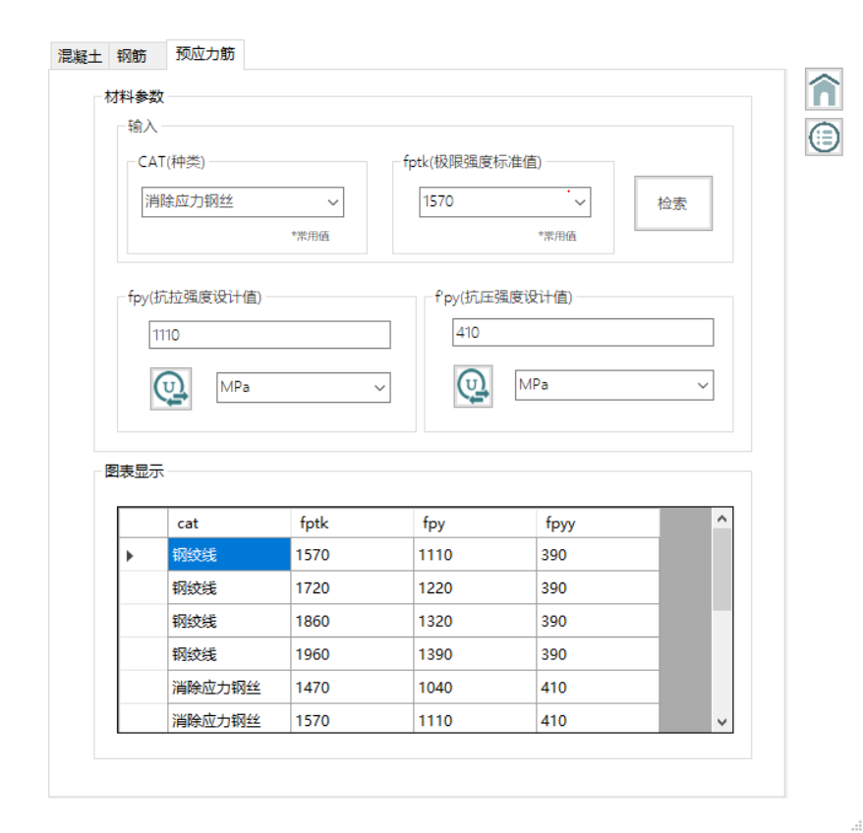
4.5 构件计算页面
4.5.1 主页面设计
1）代码实施
//跳转页面
public partial class Form2 : Form
{
public Form2()
{
InitializeComponent();
}

private void button1_Click(object sender, EventArgs e)
{
Form3 fr = new Form3();
fr.ShowDialog();
}

private void button2_Click(object sender, EventArgs e)
{
Form4 fr = new Form4();
fr.ShowDialog();
}

private void button4_Click(object sender, EventArgs e)
{
Form5 fr = new Form5();
fr.ShowDialog();
}
private void button5_Click_1(object sender, EventArgs e)
{
Form6 fr = new Form6();
fr.ShowDialog();
}
}
- 页面设计
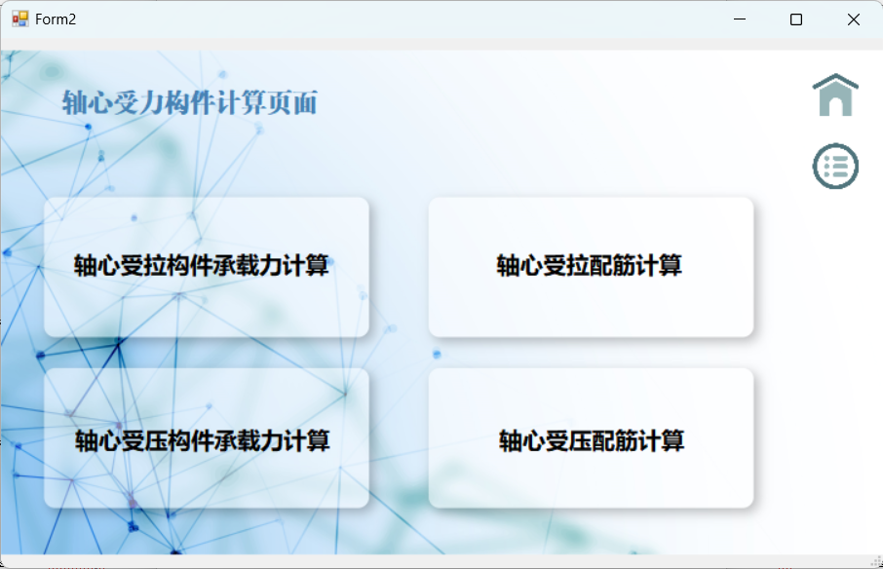

4.5.2 轴心受拉构件承载力计算
1）材料参数查表
//填充comboBox
SqlHelper obj = new SqlHelper();
public void comselect()
{

string sql = "select Strength from Concrete";
DataSet ds = obj.Getselver(sql);
if (ds.Tables[0].Rows.Count > 0)
{
for (int i = 0; i < ds.Tables[0].Rows.Count; i++)
{
comboBox1.Items.Add(ds.Tables[0].Rows[i][0].ToString());
}
}
}
public void comselect1()
{

string sql = "select brand from Steel";
DataSet ds = obj.Getselver(sql);
if (ds.Tables[0].Rows.Count > 0)
{
for (int i = 0; i < ds.Tables[0].Rows.Count; i++)
{
comboBox2.Items.Add(ds.Tables[0].Rows[i][0].ToString());
}
}
}
//数据查询
private void comboBox1_SelectedIndexChanged(object sender, EventArgs e)
{
string sql = string.Format("select EC from Concrete where Strength='" + comboBox1.Text + "'");
DataSet ds = new DataSet(); ;
ds = obj.Getselver(sql);
DataTable dt = ds.Tables[0];
textBox5.Text = dt.Rows[0][0].ToString();
}

private void comboBox2_SelectedIndexChanged(object sender, EventArgs e)
{
string sql = string.Format("select fy from Steel where brand='" + comboBox2.Text + "'");
DataSet ds = new DataSet(); ;
ds = obj.Getselver(sql);
DataTable dt = ds.Tables[0];
textBox6.Text = dt.Rows[0][0].ToString();
}
- 输入构件参数
if (textBox5.Text == "" || textBox6.Text == "" || textBox1.Text == "" || textBox2.Text == "" || textBox3.Text == "")
{
MessageBox.Show("请填写完整数据");
return;
}
double Ec = double.Parse(textBox5.Text);
double A = double.Parse(textBox1.Text);
double K = double.Parse(textBox3.Text);
double fy = double.Parse(textBox6.Text);
double As = double.Parse(textBox2.Text);
- 公式计算
double aa3 = Ec * A * K / 1000;
double aa6 = fy * As / 1000;
if (aa3 > aa6)
{
textBox4.Text = aa3.ToString();
}
else
{
textBox4.Text = aa6.ToString();
}
- 页面设计
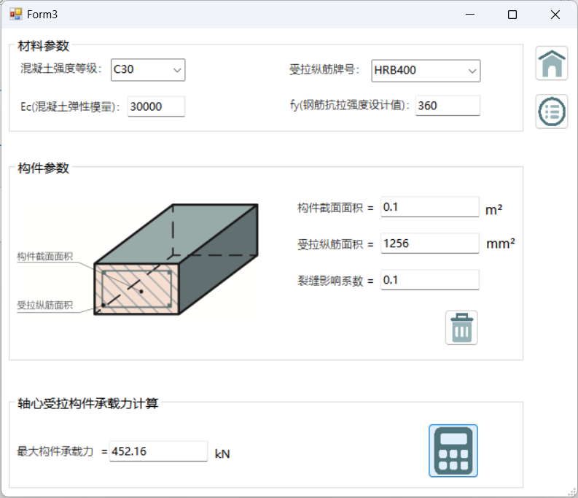

4.5.3 轴心受拉构件配筋计算
1）材料参数查表
//与4.4.1相似，故省略
2）输入构件参数
private void button2_Click(object sender, EventArgs e)
{
if (textBox4.Text == "" || textBox6.Text == "" || textBox1.Text == "" || textBox2.Text == "" || textBox3.Text == "")
{
MessageBox.Show("请填写完整数据");
return;
}
double N = double.Parse(textBox2.Text);
double fy = double.Parse(textBox6.Text);
double Min = double.Parse(textBox3.Text);
double A = double.Parse(textBox1.Text);

- 公式计算
double aa2 = N * 1000 / fy;
double aa5 = Min / 100 * A;
if (aa2 > aa5)
{
textBox5.Text = aa2.ToString("#0.000");
}
else
{
textBox5.Text = aa5.ToString("#0.000");
}
- 页面设计
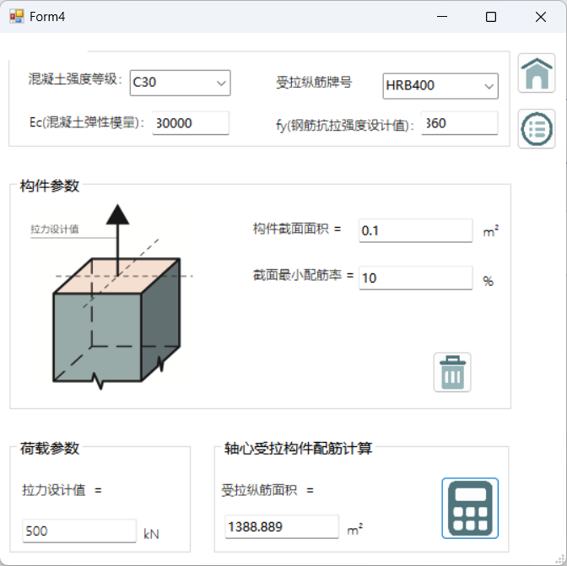
4.5.4 轴心受压构件承载力计算
1）材料参数查表
//与4.4.1 相似，故省略
2）选择截面类型与控件可见性
//通过comboBox3的值（矩形/圆形）来控制输入控件的可见性和配图
//矩形：输入a、b；圆形：输入：d
private void comboBox3_SelectedIndexChanged(object sender, EventArgs e)
{
if (comboBox3.Text == "矩形")
{
pictureBox1.Image = Image.FromFile(@"E:\4-02\数据库\项目\pic\p3-2.jpg");

label5.Visible = true;
label6.Visible = true;
label7.Visible = true;
label13.Visible = true;
label10.Visible = true;
label14.Visible = true;
label8.Visible = true;
label9.Visible = true;
textBox1.Visible = true;
textBox2.Visible = true;
textBox3.Visible = true;
textBox5.Visible = true;
textBox6.Visible = false;
label3.Visible = false;
label4.Visible = false;
}
if (comboBox3.Text == "圆形")
{
pictureBox1.Image = Image.FromFile(@"E:\4-02\数据库\项目\pic\p3-1.jpg");
label5.Visible = false;
label6.Visible = false;
label7.Visible = true;
label13.Visible = true;
label10.Visible = true;
label14.Visible = true;
label8.Visible = false;
label9.Visible = false;
textBox1.Visible = false;
textBox2.Visible = false;

textBox3.Visible = true;
textBox5.Visible = true;
textBox6.Visible = true;
label3.Visible = true;
label4.Visible = true;
}
}

private void Form5_Load(object sender, EventArgs e)
{
label4.Visible = false;
label3.Visible = false;
textBox6.Visible = false;
label5.Visible = false;
label6.Visible = false;
label7.Visible = false;
label8.Visible = false;
label9.Visible = false;
label10.Visible = false;
label13.Visible = false;
label14.Visible = false;
textBox1.Visible = false;
textBox2.Visible = false;
textBox3.Visible = false;
textBox5.Visible = false;
}
实现页面：
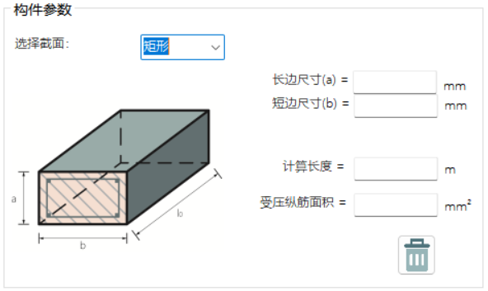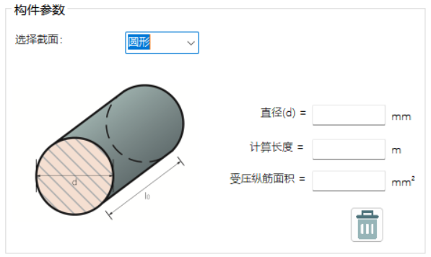
- 输入构件参数
if (comboBox3.Text == "矩形")
{
if (textBox1.Text == "" || textBox2.Text == "" || textBox3.Text == "" || textBox5.Text == "" || textBox7.Text == "" || textBox8.Text == "")
{
MessageBox.Show("请填写完整数据");
return;
}
double len = double.Parse(textBox3.Text);
double b = double.Parse(textBox2.Text);
double fc=double.Parse(textBox8.Text);
double fy=double.Parse(textBox7.Text);
double a=double.Parse(textBox1.Text);
double As=double.Parse(textBox5.Text);

长细比计算
//矩形长细比计算
double ratio = len * 1000 / b;
//以矩形为例的稳定系数计算方式
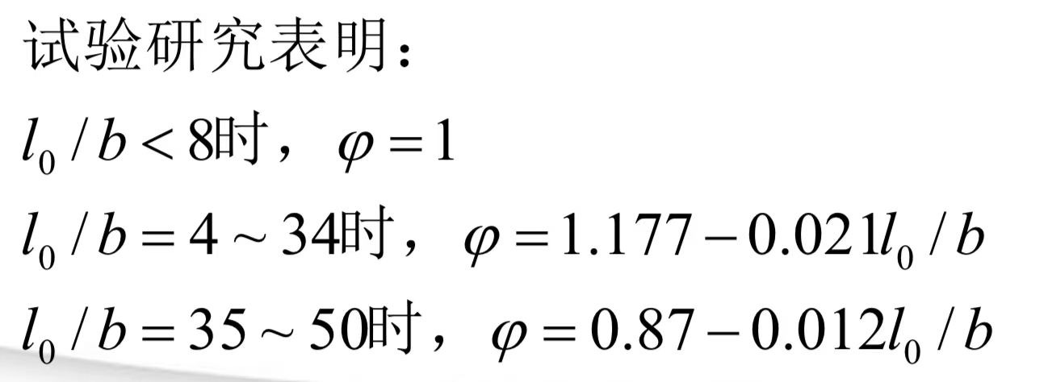
double stable;
if (ratio < 8)
{
stable = 1;
textBox9.Text = stable.ToString();
}
if (ratio >= 8 && ratio < 34)
{
stable = 1.177 - 0.021 * ratio;
textBox9.Text = stable.ToString();
}
if (ratio >= 34 && ratio < 50)
{
stable = 0.87 - 0.012 * ratio;
textBox9.Text = stable.ToString();
}
if (ratio > 50)
{
MessageBox.Show("长细比过大，不够稳定！");
return;
}
- 公式计算
double Ncu = 0.9 * aa7 * (fc * b * a + fy * As) / 1000;
textBox4.Text = Ncu.ToString("#0.000");
- 页面设计
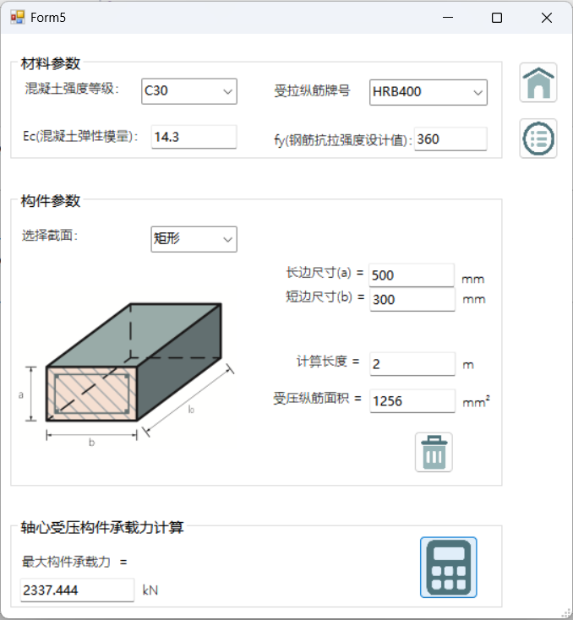

4.4.5 轴心受压构件配筋计算
1）材料参数查表
//与4.4.1相似，故省略
- 选择截面类型与控件可见性
//与4.4.3相似，故省略
- 由长细比计算稳定系数
//与4.4.3相似，故省略
- 构件参数输入
private void button1_Click(object sender, EventArgs e)
{
if (comboBox3.Text == "矩形")
{
if (textBox1.Text == "" || textBox2.Text == "" || textBox3.Text == "" || textBox10.Text == "" || textBox5.Text == "" || textBox8.Text == "")
{
MessageBox.Show("请填写完整数据");
return;
}
double len = double.Parse(textBox3.Text);
double b = double.Parse(textBox2.Text);
double fc = double.Parse(textBox8.Text);
double fy = double.Parse(textBox5.Text);
double a = double.Parse(textBox1.Text);
double Ncu = double.Parse(textBox10.Text);
if (comboBox3.Text == "圆形")
{
if (textBox6.Text == "" || textBox3.Text == "" || textBox8.Text == "" || textBox5.Text == "" || textBox10.Text == "")
{
MessageBox.Show("请填写完整数据");
return;
}
double len = double.Parse(textBox3.Text);
double d = double.Parse(textBox6.Text);
double fc = double.Parse(textBox8.Text);
double fy = double.Parse(textBox5.Text);
double Ncu = double.Parse(textBox10.Text);

- 公式计算
//矩形公式
double As1 = (Ncu *1000 / (0.9 * aa7) - fc * a * b) / fy;
if (As1 < 0)
{
As1 = 0.006 * a * b;
}
textBox4.Text = As1.ToString("#0.000");
//圆形公式
double As2 = (Ncu *1000 / (0.9 * S) - fc * 3.14 * 0.25 * d * d) / fy;
if (As2 < 0)
{
As2 = 0.006 * d * d;
}
textBox4.Text = As2.ToString("#0.000");
- 页面设计
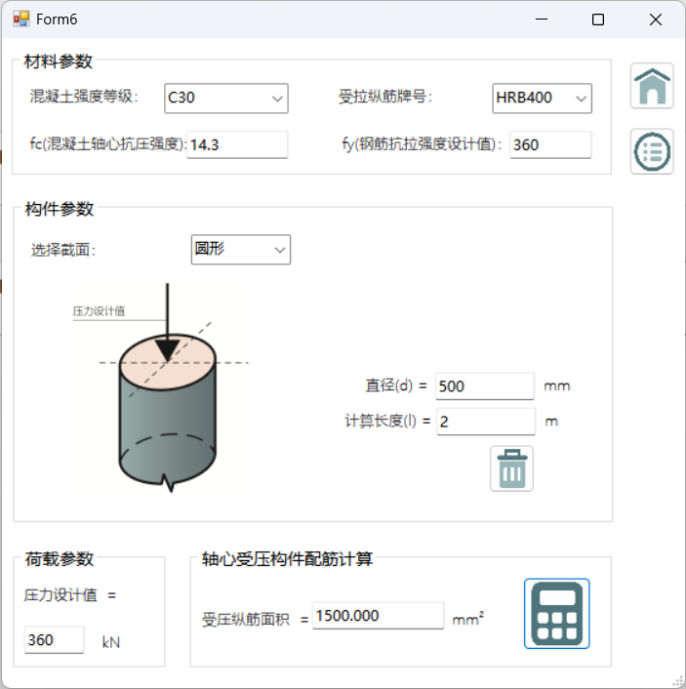

五、系统测试
六、小组分工与自我评述
6.1分工情况
学号 | 姓名 | 工作内容
1953961 | 黄芷仪 | 数据库建立表1、2，c#设计主页、构件计算页面、PPT与报告整理
2152017 | 钱浦玥 | 数据公式整理，概念、逻辑模式设计、PPT与报告整理
2054136 | 唐音奇 | 数据库建立表3，c#软件介绍页、构件数据查询页、PPT与报告整理
6.2评述优点
（1）界面清晰美观，便于用户快速上手使用
（2）功能性强，提高用户计算与学习效率
（3）整体具有较高流畅度
6.3不足与改进之处
（1）可增加用户引导、数据存储功能，优化用户体验感。
（2）可融合更多非轴心受力构件的计算模块，丰富计算工具箱的选择内容模块。
（3）由于是受力构件计算与配筋工具箱，需要较高的学科专业度、准确度，可能要考虑更多因素对实际选择设计的影响。

七、课程学习体会
（1）数据库课程的学习需要耐心和认真的态度。从前面的实验学习到做项目的过程中，我们都遇见了许多技术难题，基础的构件计算系统也需要进行很多次修改、困难攻克。为了保证本项目计算结果的精度，每一个数据、细节都需要保证其完整、准确。

（2）实践至关重要。数据库的学习不可只停留于纸面，真正的“学会”在于吃透书本知识后加以实践。做项目就是一个实践的过程，能够帮助我们更好地理清思路、查缺补漏，让我们更好更熟练地掌握知识、构建框架。学习中要不断思考与总结，提高运用程度，学习能力才能逐步提升。
（3）团队合作在项目构件中至关重要。在小组作业中，团队合作是完成项目的基石。从选定项目主题到分组逐步建立项目到总结整理，每一个环节都是需要组员进行讨论、沟通与衔接，一起解决项目构建中存在的问题。在良好的团队合作与组员的积极沟通下，我们的项目才得以顺利完成。

说明：报告内容长度不限，言之有物即可。正文字体大小为五号，标题依次递增。

